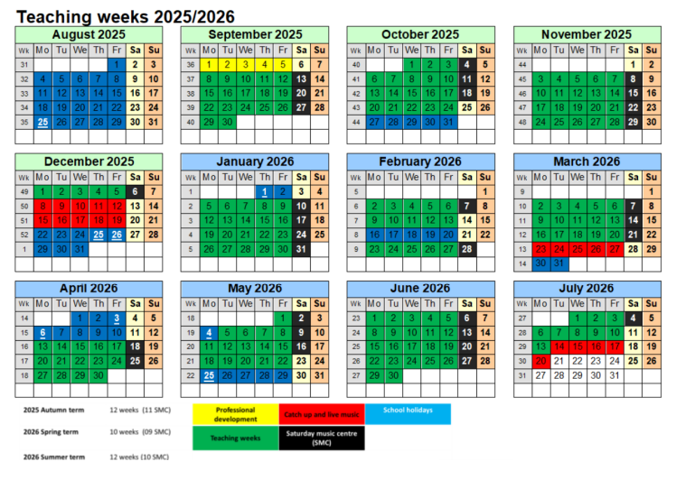
The non-teaching days do not strictly mean that the service will not be teaching. They may come in to make up some time they have had absent/sort instruments however, at times they may also be on training.
Expect your first session with the service w/c 8th Sep
New Delivery 25/26 - 2 classes (rotation):
Please note that all staff must inform the music service of any children with additional needs prior to the sessions starting at the beginning of the year so they can prepare for these children where possible. This can be done by emailing the information to the music lead.
If necessary, this should be completed in the sets the children attend lessons rather than a class list.
Year Group | Lesson | Timetable
Reception | Kapow (GB) | Friday
Year 1 | Kapow (GB) | Friday
Year 2 | Curriculum Lesson | Tuesday
Year 3 | Recorder Lessons | Tuesday
Year 4 | Brass (Rotation) | Wednesday
Year 5 | Ukulele | Tuesday
Year 6 | Guitar (Rotation) | Tuesday
Launch Pad | Curriculum Lesson | Friday

 | Half Term 1 | Half Term 2
Year 4 | Haiku, music and performance (Theme: Hanmai Festival) | Samba and Carnival Sounds (Theme: South America)
Year 6 | Film Music | Theme and Variation (Theme: Pop Art)
3 form Music curriculum 25/26
Year 1 | Music Curriculum Overview
Autumn 1 | Pulse and rhythm (Theme: All About Me)
Autumn 2 | Classical music, dynamics and tempo (Theme: Animals_
Spring 1 | Timbre and rhythmic patterns (Theme: Fairytales)
Spring 2 | Pitch and tempo (Theme: Super heroes)
Summer 1 | Vocal and body sounds (Theme: By the Sea)
Summer 2 | Musical Vocabulary (Under the sea)

Reception | Music Curriculum Overview
Autumn 1 | Music within continuous provision
Autumn 2 | Celebration Music
Spring 1 | Exploring sound
Spring 2 | Music and movement
Summer 1 | Musical stories
Summer 2 | Big Band

